**CitiBike Analysis**

Chosen Time Period: Jan 2018 – March 2019

How many trips have been recorded total during the chosen period?

With the filters I had in place, leaving out any “Unknown” Gender and anyone over 89, there were a total of 21,075 trips.

By what percentage has total ridership grown?

Ridership grew from 566 in January 2018 to 1,556 in March 2019, a percentage growth of 275%.

How has the proportion of short-term customers and annual subscribers changed?

The proportion of short-term customers to annual subscribers has grown from being about 1/8 of total ridership to 1/3.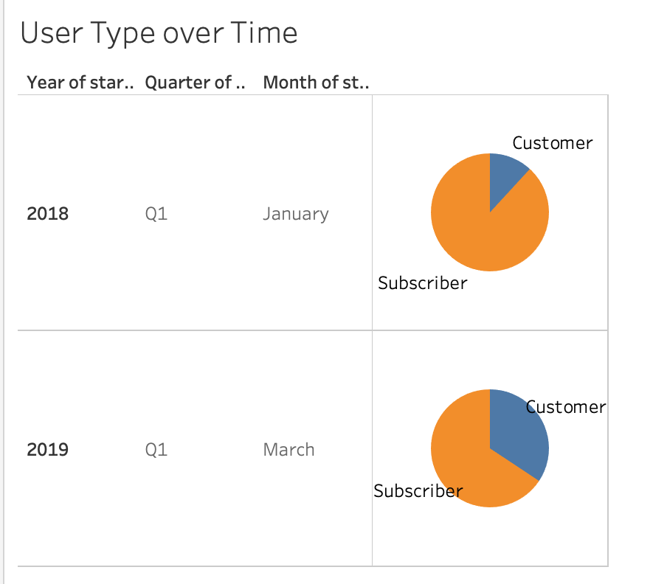

What are the peak hours in which bikes are used during summer months?

Peak hours in summer months occur from around 3pm to 7pm, when the late afternoons and early evenings are presumably balmy and pleasant.

What are the peak hours in which bikes are used during winter months?

Peak hours in the winter months are at around 8am and 5pm, when commuters go to and from work perhaps.

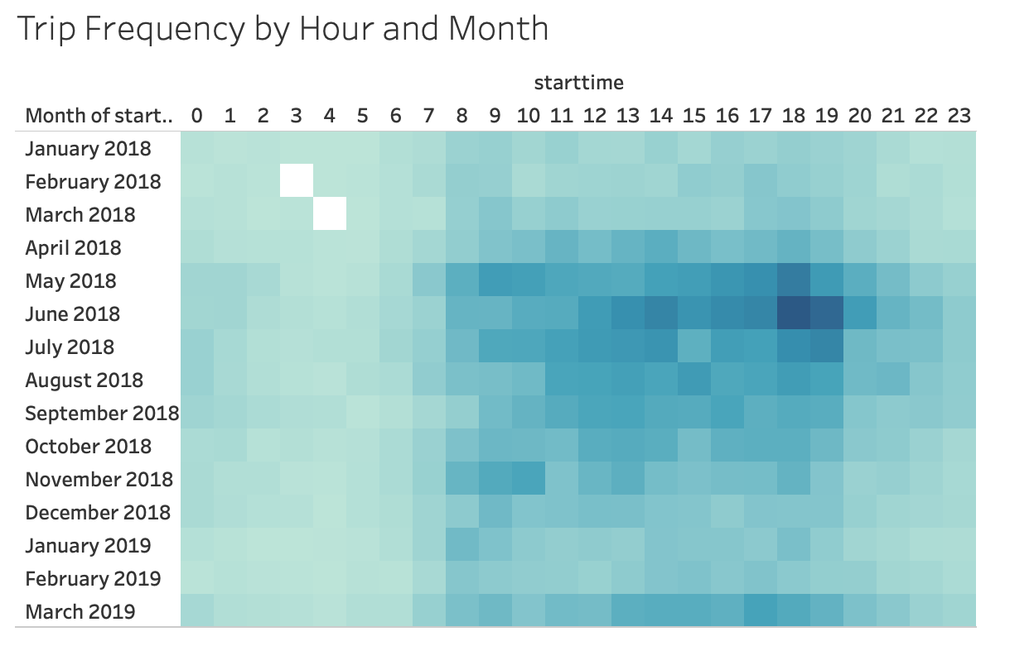

Today, what are the top 10 stations in the city for starting a journey? (Based on data, why do you hypothesize these are the top locations?) I hypothesize that the top locations have to do with their proximity to Central Park and other city hubs. They also allow for further commute based on their proximity to subway stations too.

The top ten start stations have been:

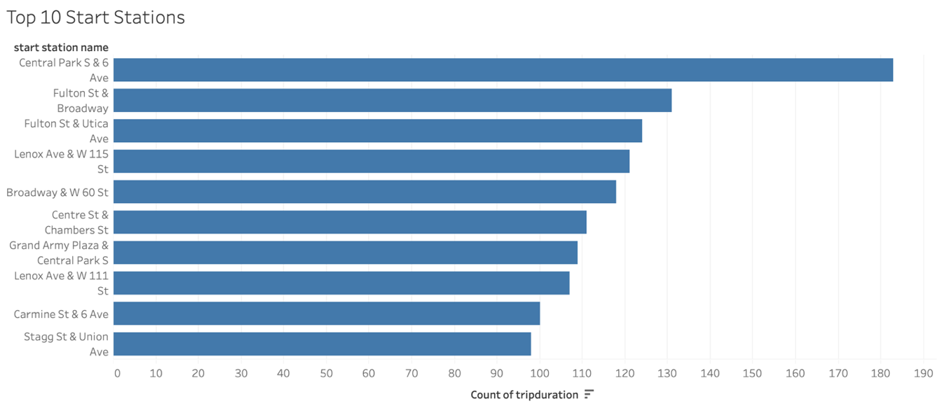

The bottom ten start stations have been:

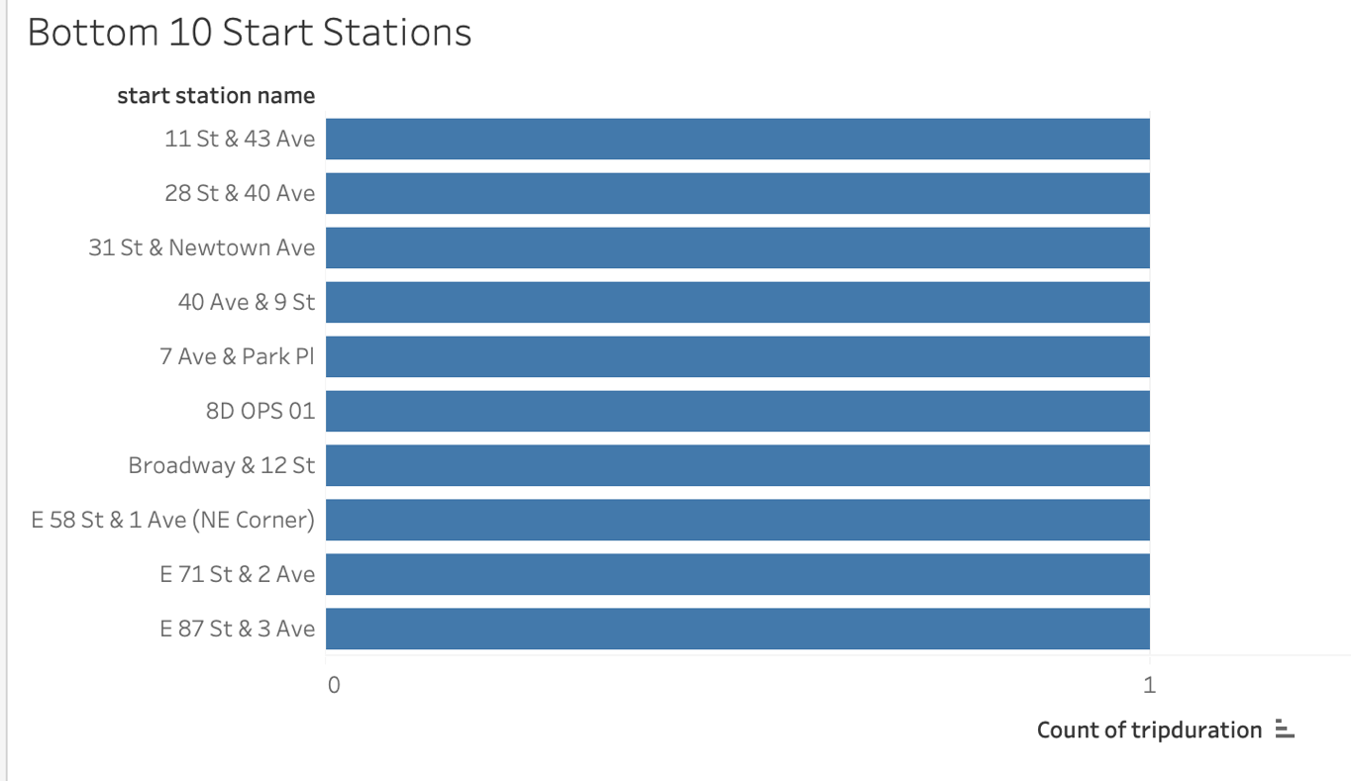

The top ten end stations have been:

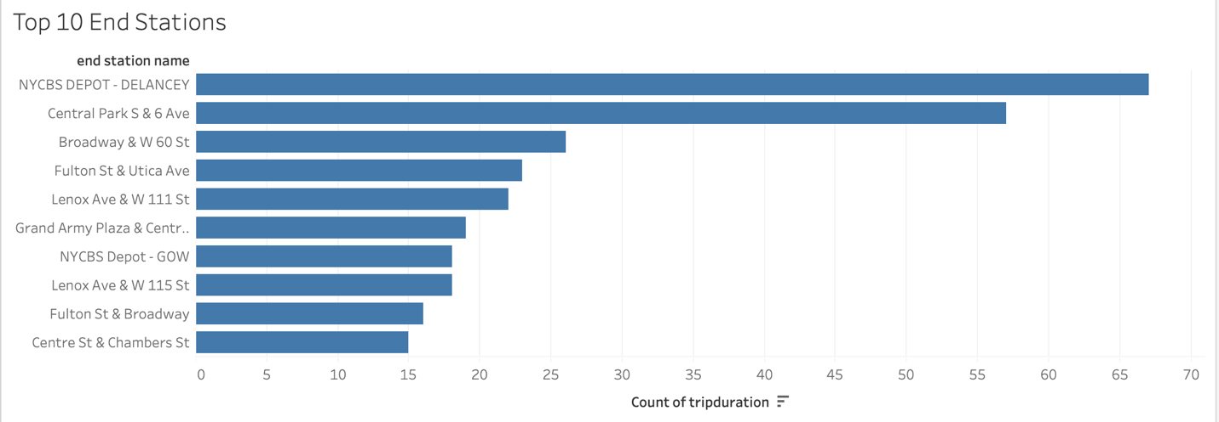

The bottom ten end stations have been:

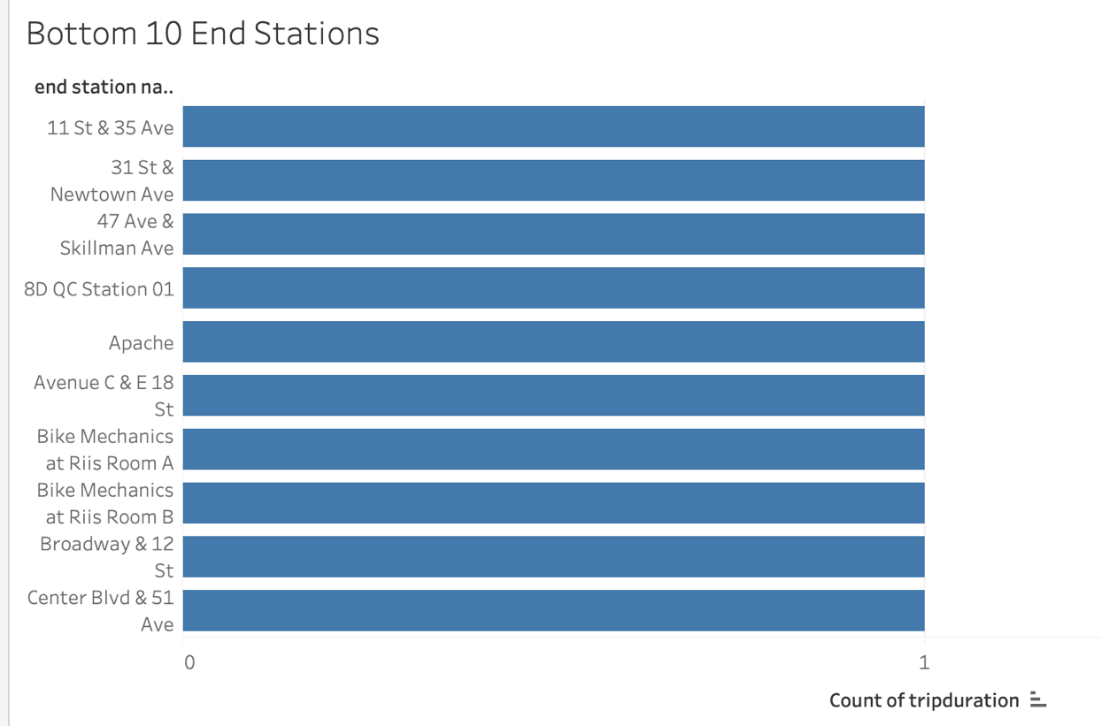

Today, the top 10 start stations are:

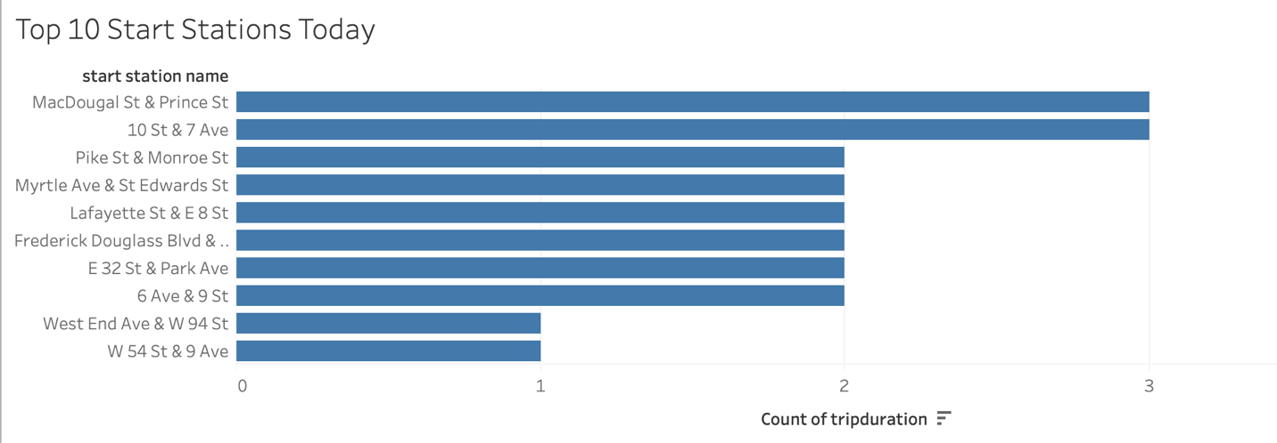

Today, the top 10 end stations are: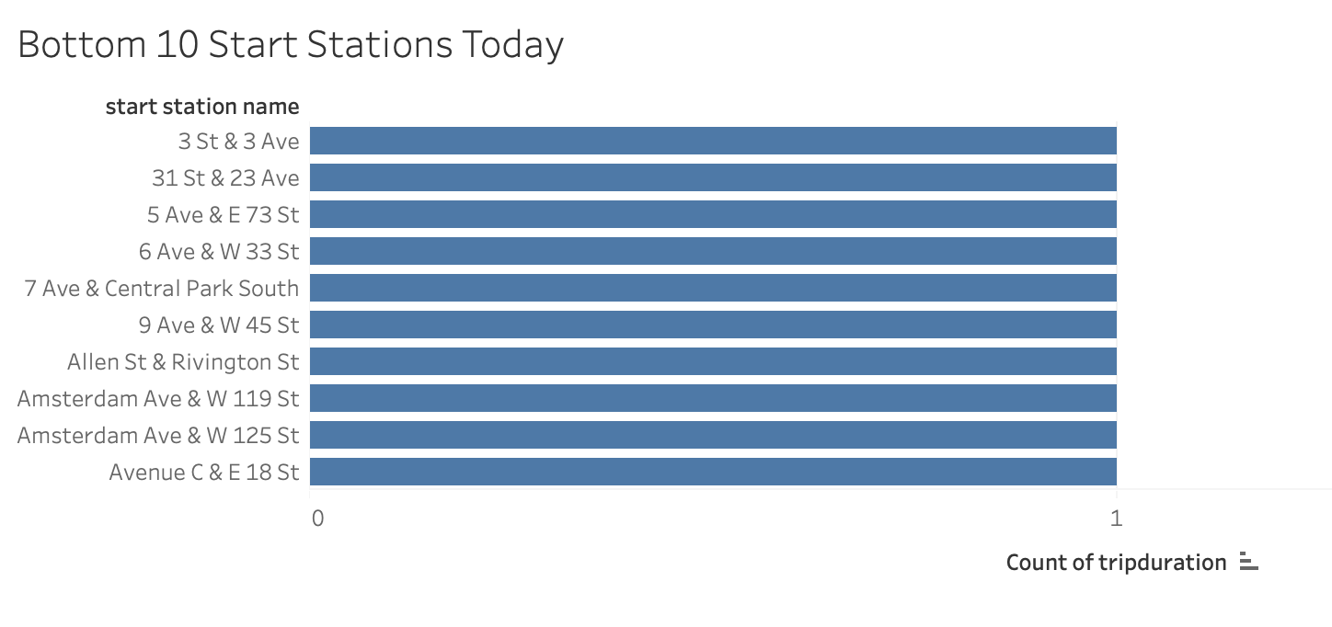

Today the bottom 10 start stations are: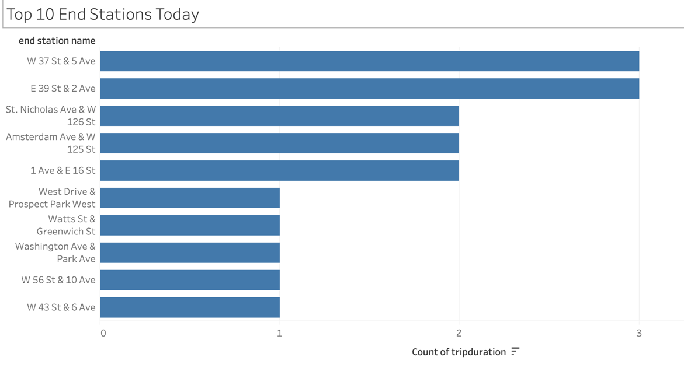

Today the bottom 10 end stations are:

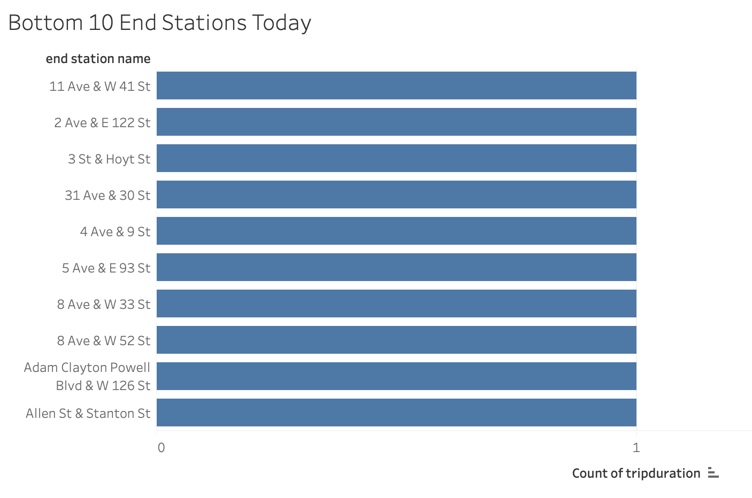

How effective has gender outreach been in increasing female ridership over the timespan?

The gender outreach has had mixed success, with female riders surging proportionate with an overall increase in ridership. In the summer months, the ratio of men to women seems to lessen, with women making a slightly larger part than through the rest of the year.

How does the average trip duration change by age?

The average trip is longest for those in their thirties, by a long shot. Riders in their forties and twenties are almost neck and neck for second longest trips. This could be accounted for by the fact that these groups also have the greatest number of riders overall, skewing the results.

What is the average distance in miles that a bike is ridden?

Which bikes (by ID) are most likely due for repair or inspection in the timespan?

How variable is the utilization by bike ID?

Additionally, city officials would like to see the following visualizations:

A static map that plots all bike stations with a visual indication of the most popular locations to start and end a journey with zip code data overlaid on top.

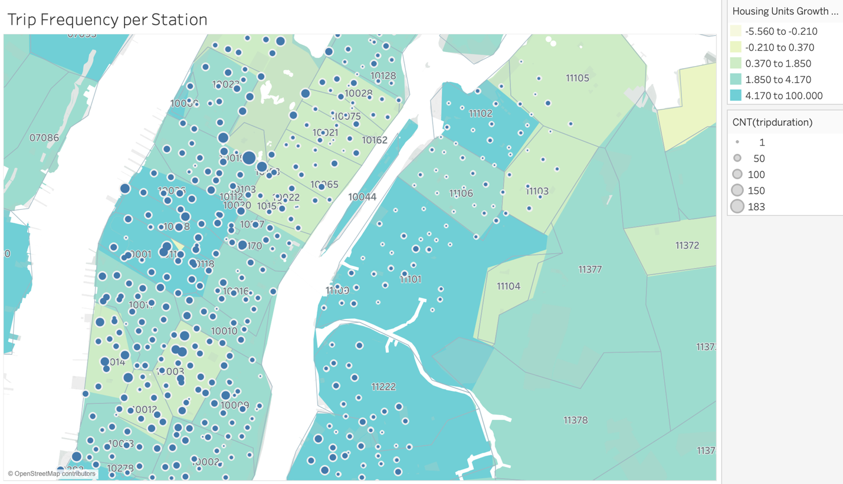

Find at least two unexpected phenomena in the data and provide a visualization and analysis to document their presence.

The only age group that has a greater female ridership than male is the eighties group. Female ridership also grew more than male ridership in the summer months overall.

